

led by: Pastor Josh Franklin, Good Hope Baptist Church (www.goodhopechurch.org and www.joshfranklin.org)

Getting Right with God
A Quick Look at the Letter to the Romans
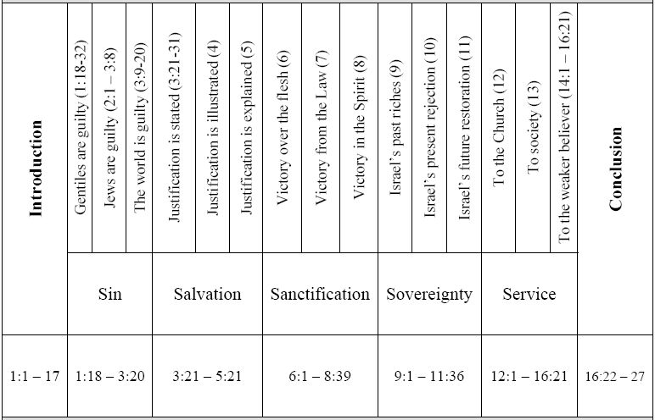
Fast Facts on Romans

1. Who? Apostle Paul

2. When? 57 AD

3.Why? To give a systematic understanding of what Jesus’ death, burial and resurrection meant for all people, and how they can be made right with God.

4. Where Written? Corinth
(3rd Missionary Journey)

5. Key Phrase:
Paid in Full

Chart Source: Danny Akin

Reading Romans You’ll Understand How…

_________ - I’m Totally ______ (ch. 1-3) Sin means refusing to do God's will and failing to do all that God wants. Since Adam's rebellion against God, our nature is to disobey him. Our sin cuts us off from God. Sin causes us to want to live our own way rather than God's way. Because God is morally perfect, just, and fair, he is right to condemn sin.

______________ - I’m Totally _________ (ch. 3-6) Our sin points out our need to be forgiven and cleansed. Although we don't deserve it, God, in his kindness, reached out to love and forgive us. He provides the way for us to be saved. Christ's death paid the penalty for our sin.

________________ - I’ve Got A New _______ (ch. 6-9) By God's power, believers are sanctified -- made holy. This means we are set apart from sin, enabled to obey and to become more like Christ. When we are growing in our relationship with Christ, the Holy Spirit frees us from the demands of the law and from fear of judgment.

________________ - I’ve Got A New _______ (ch. 9-12) God oversees and cares about his people -- past, present, and future. God's ways of dealing with people are always fair. Because God is in charge of all creation, he can save whomever he wills.

________________ - I’ve Got A New _______ (ch. 12-16) When our purpose is to give credit to God for his love, power, and perfection in all we do, we can serve him properly. Serving him unifies all believers and enables them to show love and sensitivity to others.

LIFE APPLICATION FROM ROMANS:
ROMANS 1-3 - OWN UP TO THE FACTS - Each person has sinned, either by rebelling against God or by ignoring his will. No matter what our background or how hard we try to live good and moral lives, we cannot earn salvation or remove our sin. Only Christ can save us.

ROMANS 3-6 - BELIEVE IN GOD’S UNCHANGING STORY - It is good news that God saves us from our sin. But we must believe in Jesus Christ and believe that he forgave our sin in order to enter into a wonderful new relationship with God.

ROMANS 6-9 - DETERMINE TO GROW UP SPIRITUALLY - Because we are free from sin's control, the law's demands, and fear of God's punishment, we can grow in our relationship with Christ. By trusting in the Holy Spirit and allowing him to help us, we can overcome sin and temptation.

ROMANS 9-12 - ALLOW GOD TO BE IN THE DRIVER’S SEAT OF YOUR LIFE - Because of God's mercy, both Jews and Gentiles can be saved. We all must respond to his mercy and accept his gracious offer of forgiveness. Because he is sovereign, let him reign in your heart.

ROMANS 12-16 - LOVE GOD’S CHILDREN, NO MATTER WHAT! - None of us can be fully Christlike by ourselves -- it takes the entire body of Christ to fully express Christ. By actively and vigorously building up other believers, Christians can be a symphony of service to God.

Biblical References to Homosexuality (source: Danny Akin)

1. Sodomy (Gen. 19:4-10; Deut. 23:17-18; I Kings 14:24, 15:11-12; II Kings 23:7)
2. Abomination (Lev. 18:22; Deut. 22:5)
3. Vile affections (Rom. 1:26-27)
4. Burning with lust (Rom. 1:27)
5. Dishonoring the body (Rom. 1:24)
6. Wickedness (Gen. 13:13, 14:7; Judges 19:23)
7. Violating nature (Rom. 1:26)
8. Shameful lust (Rom. 1:27)
9. Lusting for strange flesh (Jude 7)
10. Filthy dreamers (Jude 7-8)
11. Abusers of themselves (I Cor. 6:9)
12. Effeminate (I Cor. 6:9)
13. Defilers of themselves (I Tim. 1:9-10)
14. Inordinate affections (Col. 3:5-6)
15. Reprobate (Rom. 1:28)

Biblical Facts Concerning Sodomy, Lesbianism, and Homosexuality
As Taught in Romans 1 and the Whole of Scripture (source: Danny Akin)
1. It is sin, not sickness (cf. Gen. 18:20ff; Lev. 18:22, 29; 20:13; Rom. 1:18-32; I Cor. 6:9; I Tim. 1:10; Jude 7)
2. It is the ultimate manifestation of a society turned from God.
3. It is wrong by nature’s standards.
4. It leads to rampant sin in other areas.
5. It is inconsistent with a Christian lifestyle.
6. It can be forgiven and conquered.
7. Homosexuals who truly repent and turn to Christ should be accepted, as any other “sinner saved by grace”.
8. Homosexuals who refuse to repent and deny it as sin should be loved and witnessed to.

Answers:

…SIN - I’m Totally Lost (ch. 1-3)
…SALVATION - I’m Totally Loved (ch. 3-6)
…SANCTIFICATION - I’ve Got A New Life (ch. 6-9)
…SOVEREIGNTY - I’ve Got A New Lord (ch. 9-12)
…SERVICE - I’ve Got A New Love (ch. 12-16)

General Characteristics of the Book
1. The most systematic of Paul’s letters. It reads more like a developed theological essay than a letter.
2. Emphasis on Christian doctrine. The number and importance of the theological themes touched upon are impressive: sin, salvation, grace, faith, righteousness, justification, sanctification, redemption, death, resurrection, eschatology, and divine sovereignty.
3. Widespread use of OT quotations. Although Paul regularly quotes from the OT in his letters, in Romans the argument is sometimes carried along by such quotations (see especially 3:9-20; chs. 9–11).
4. Deep concern for Israel. Paul writes about her present status, her relationship to the Gentiles, and her final salvation.

Observations of Interest
1. Rome was the capital of the Roman Empire and therefore the most strategic city for Christian missions. Population: estimated at over 4,000,000.
2. Nero (A.D. 54–68) was reigning as emperor in his early and more sane days.
3. Romans is the longest of Paul’s letters, thus the reason it heads the Pauline corpus in our New Testament.
4. Paul quotes from the OT in this letter more than in all the other Pauline letters together. There are at least 61 direct quotations from 14 different books. Psalms and Isaiah are the most frequently quoted.
5. This book is often called Paul’s magnum opus (major or ultimate work). Martin Luther (1483–1546) called it “the masterpiece of the New Testament.”

Romans, Paul’s greatest work, is placed first among his thirteen epistles in the New Testament. While the four Gospels present the words and works of Jesus Christ, Romans explores the significance of His sacrificial death. Using a question-and-answer format, Paul records the most systematic presentation of doctrine in the Bible. Romans is more than a book of theology; it is also a book of practical exhortation. The good news of Jesus Christ is more than facts to be believed; it is also a life to be lived—a life of righteousness befitting the person “justified freely by His [God’s] grace through the redemption that is in Christ Jesus”.
Romans was not the first of Paul’s epistles, but it was appropriately placed at the beginning of the Pauline corpus not only because it was Paul’s longest work, but because it provides the doctrinal foundation upon which the other epistles are built. It is the most systematic and detailed exposition of theological truth in the Scriptures. Romans concentrates on the doctrines of hamartiology (sin) and soteriology (salvation): just as all men (Jews and Gentiles) are sinners, so God has graciously extended His offer of salvation to all who will place their faith in Christ.
Romans is the most formal of Paul’s writings—it is more of a treatise than a letter. Paul was a stranger to most of the Roman believers (hence the long introduction), and he did not seek to refute any specific errors in their church. This is primarily a preventative, not a corrective epistle, and Paul made skillful use of a debate format to refute the kinds of objections he had encountered during two decades of reflecting upon and defending the gospel. The result is one of the most forceful, logical, and eloquent works ever penned. It is safe to say Romans has influenced the subsequent history of the church more than any other epistle.

Church at Rome
Paul did not found the church at Rome, and the tradition that Peter was its founder is contrary to the evidence. It is possible that it began when some of the Jews and proselytes to Judaism who became followers of Christ on the Day of Pentecost (cf. Acts 2:10) returned to Rome, but it is more likely that Christians from churches established by Paul in Asia, Macedonia, and Greece settled in Rome and led others to Christ. Apparently Paul had finished his work in the east, and he planned to visit Rome on his way to Spain after first bringing a collection to Jerusalem for the poor Christians there (Rom 15:23-28).

Jerry Vines:
The book of Romans may be the most influential book ever written. It has probably had more influence on more people than anyone book of the New Testament. There are three remarkable conversions in Christian history that are a direct result of a study or a hearing or a reading of the book of Romans.
- The first is a man named Saint Augustine. As a young man, Augustine heard someone say to take and read. He picked up his Bible and was reading the book of Romans. He got to Romans 13: 14 where it says, “But put ye on the Lord Jesus Christ, and make not provision for the flesh, to fulfill its lusts:’ God used this verse to bring Augustine to know Christ as his Savior. He became one of the great theologians and great teachers of the Christian faith.
- The second is a man named Martin Luther. He was the founder of the Great Reformation. He was a Catholic monk; and in his attempt to earn the favor of God as a monk, he began to study the book of Romans. He became convinced that a person could not earn the favor of God and that it was only grace that made it possible for anyone to be saved. As a result of the study of the book of Romans, Martin Luther came to Christ; and he shook the world. The Protestant Reformation was a direct result of his study of the book of Romans.
- The third man is John Wesley. He was the founder of the Methodist movement and one of the great Christians in the history of the Christian faith. He came to the new world as a missionary to the colonists and Georgian Indians. On his voyage, he encountered some German Moravian missionaries and became convinced they had something he did not have. Wesley said, “I went to Georgia to convert the Indians, but who will convert me?” He went into a little chapel one night and heard someone reading Martin Luther’s introduction to the book of Romans. Wesley said, “I felt my heart strangely warmed.” As a result of that experience, John Wesley came to know Christ as his personal Savior.

- John Chrysostom had this epistle read to him once a week for eighteen years.
- Martyn Lloyd-Jones, the great expositor of Scripture, spent fourteen years teaching through the book of Romans and yet never finished his series before he resigned from his church.
- Donald Grey Barnhouse broadcast weekly messages through Romans for eleven years on the radio.

